1.the structure of synaps.

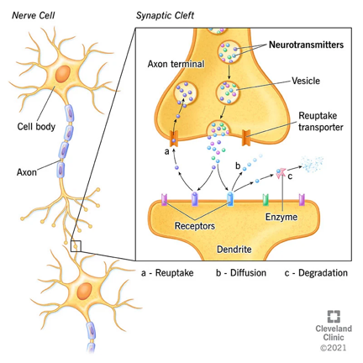



Transmitter:

What’s it: Neurotransmitters carry chemical signals (“messages”) from one neuron (nerve cell) to the next target cells. (next nerve, muscle or gland cell)

how to identify: must be synthesized and released by nerve

Full procedure of transmitters: synthesis, storage, release, response, removal

Synthesis: produced in the neural cell body

Storage: stored in vesicle

Release: released by nerve cells (one vesicle by one vesicle, on quantum level)

Response: 1. ach bind at receptor and activate

2. open ion channel and sodium come in

Removal: ach: acetylcholinesterase -> ach breakdown (works fast)

Adrenaline: reuptake into nerve

Into blood: diffusion

2.

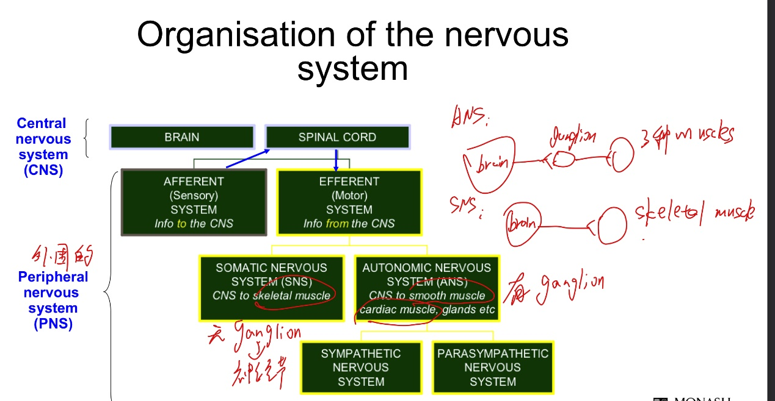



ANS:

Parasympathetic nerves: store energy

transmitters from nerves to muscles: Ach: acetylcholine and adrenaline

Sympathetic nerves: cost energy

transmitters from nerves to muscles: NA: noradrenaline

Two system inter-influence

PNS:

transmitters from nerves to muscles: Ach or NA

3.

胆碱

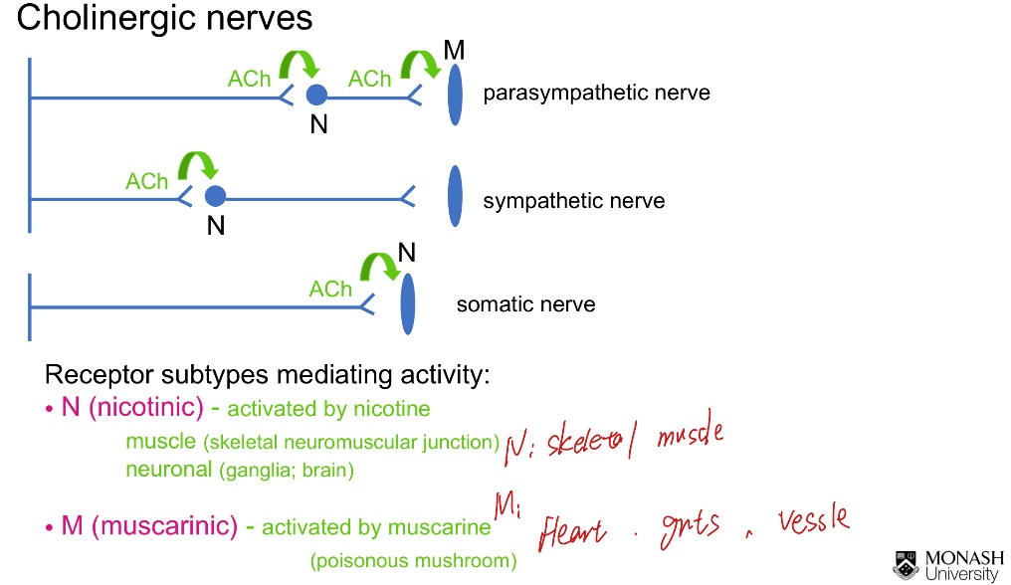

肾上腺

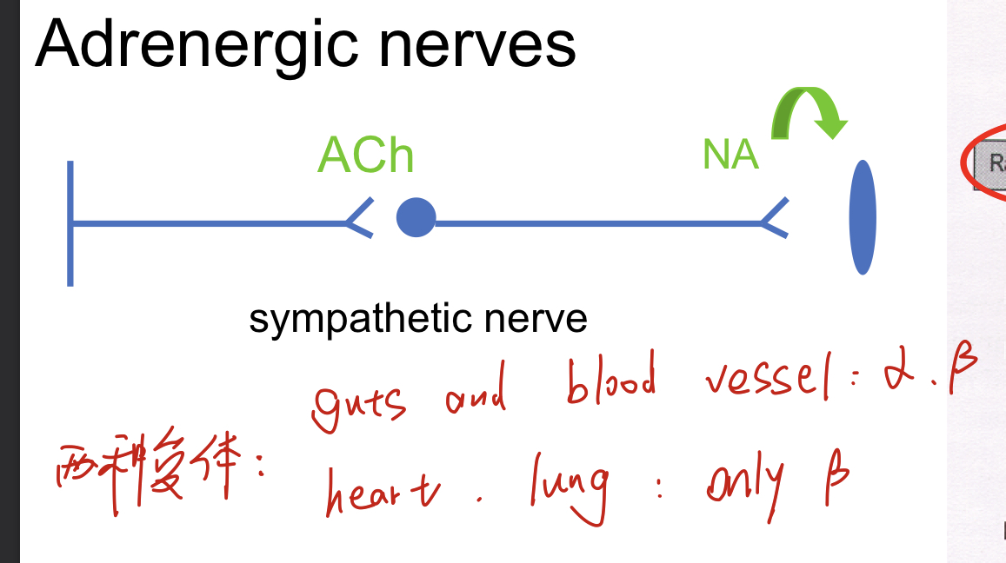

4. Neural muscle junction

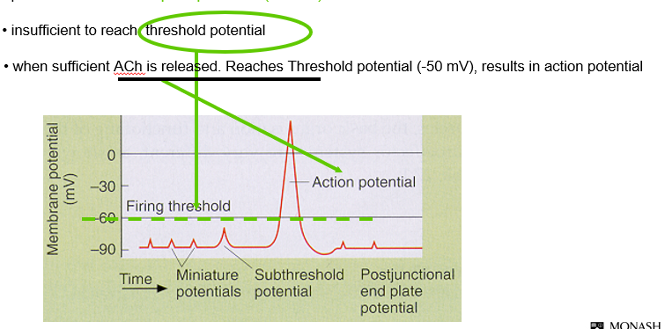

5. How post-synoptically drugs influence transmitter process: Inhibit binding; inactivate channels

Non-depolarising blockers: produce competitive antagonist at receptors, no initial stimulant action “no efficacy just affinity”

Depolarising blockers: inactive receptors; produce high doses of nicotinic agonist -> inhibit binding

6.

